Fish’s Night Song

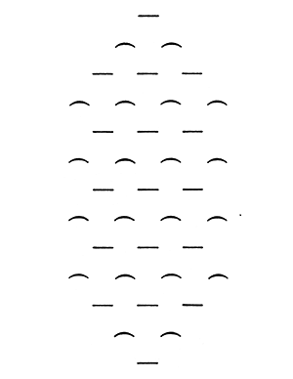

from The Gallows Songs, A Selection
Translated with intro by Max Knight
University of California Press, 1964

